**RESUME**

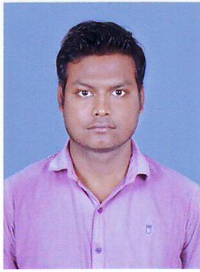

**Aditya Ghosh**

C/O- Raju Ghosh

Tiwarigali, Khetrajpur

Near Naveen Tutorials

Dist.– Sambalpur, Odisha.

**Email ID**: [aditya.ghosh.itc@gmail.com](mailto:aditya.ghosh.itc@gmail.com)

Contact No.**9090002300**

**CAREER OBJECTIVE**:

“To use my skills in the best possible ways for achieving the company’s goal as a Graduate and I would like a career that gives me rich exposure and working with the people of high caliber “

**WORK EXPERIENCE:**

DESIGNATION: **Pilot Sales Representative (PSR)**

ORGANIZATION: Imperial Tobacco Company (ITC)

Work Experience: November 2012 to June 2014

DESIGNATION: **Relationship Officer (Gold Loan)**

ORGANIZATION: Axis Bank Ltd

Work Experience: August 2014 to February 2016

DESIGNATION: **Relationship Officer (Mortgage)**

ORGANIZATION: HDFC Sales Pvt Ltd

Work Experience: October 2016 to December 2017

DESIGNATION: **Relationship Officer Mortgage)**

ORGANIZATION: Axis Bank Ltd

Work Experience: January 2018 to July’ 2018

DESIGNATION: **Sales Manager**

ORGANIZATION: HDB FINANCIAL SERVICES LTD

Work Experience: December 2018 to Till Date…

**WORK KNOWLEDGE:**

* Working from 2013 to till now in the field of Marketing and Sales.

**EDUCATIONAL QUALIFICATION:**

* 2014 - Graduate in Commerce from Sambalpur University, Sambalpur.
* 2009 - +2 Commerce from Burla NAC College, Burla, Sambalpur.
* 2007 – High School from Guru Nanak Public School (CBSE).

**COMPUTER PROFICIENCY:**

* Diploma In Computer Application (D.C.A)

Duration 6 month

**PERSONAL COMPETENCIES:**

* Communication Skill.
* Leadership Skill.
* Problem Solving Skill.

**INTEREST:**

* Reading Novels
* Listening music
* Playing DJ

**PERSONAL PROFILE:**

FATHER NAME : Raju Ghosh

DATE OF BIRTH : 04th December 1990.

SEX : Male.

MARITAL STATUS : married.

MOTHER TONGUE : Bengali.

NATIONALITY : Indian.

LANGUAGE KNOWN : Bengali – Native Language.

English – Read, write And Speak

Hindi – Read, write And Speak

Oriya – Read and Speak

**PERSONAL STRENGTH:**

I am flexible to new thoughts and can adjust at any circumstances. I like to work in group taking all members views. I believe in hard work. I constantly look out for challenges.

Aditya Ghosh

Date –

Place - Sambalpur